ADIDAS
U.S. RETAIL SALES PERFORMANCE ANALYSIS
Retailer, Regional & Channel Performance | FY2020–FY2021
Prepared for Adidas Management
Strategic Insights & Recommendations Report

Executive Summary
Analysis of 9,648 transaction records spanning January 2020 through December 2021 across six major U.S. retail partners (Foot Locker, West Gear, Sports Direct, Kohl's, Amazon, and Walmart), five regions, and three sales channels reveals a business with strong overall momentum but pronounced concentration risk across retailers, regions, and channels.
$899.9M  TOTAL SALES  FY20–FY21 combined | $332.1M  OPERATING PROFIT  36.9% of sales | 42.3%  AVG. MARGIN  Operating margin | 2.48M  UNITS SOLD  45,224 transactions/mo avg

Sales nearly quadrupled from 2020 ($182.1M) to 2021 ($717.8M) — a 294% increase — reflecting either strong post-pandemic recovery, retail footprint expansion, or a partial-year 2020 baseline. This growth was not uniform: it was heavily concentrated in specific retailers, the West region, and the Online channel, creating both an opportunity to replicate what's working and a risk if any single driver weakens.
Top-Line Findings
- Product: Men's Street Footwear is the single largest category ($208.8M, 23.2% of sales) and carries the highest margin (44.6%).
- Retailer: West Gear ($243.0M, 27.0%) and Foot Locker ($220.1M, 24.5%) together generate over half of all revenue; Walmart is the weakest partner at just 8.3%.
- Region: The West region leads with $269.9M (30.0% of sales), while the Midwest lags at $135.8M (15.1%).
- Channel: In-store still leads on total revenue (39.6%), but Online carries the highest margin (46%) and the highest unit volume — signalling a structural shift worth monitoring.
- Trend: Sales grew in every quarter of 2021 versus 2020, peaking in Q3 2021 ($210.0M) before a modest Q4 pullback ($190.1M).

1. Overall Sales & Profitability Performance
Total operating profit reached $332.1M on $899.9M of sales, an overall operating margin of 42.3% — a healthy level for an athletic apparel/footwear business, and consistent across most segments (margins ranged narrowly from 40.3% to 44.6% by product category).
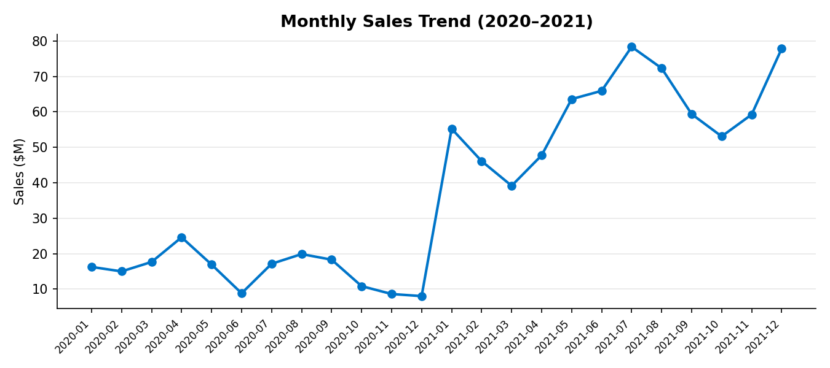
The monthly trend shows clear seasonality layered on top of strong underlying growth: sales dip in mid-year (Jun 2020) and again in early Q1, before building toward Q3 peaks. 2021 shows a much smoother, higher-volume pattern than the choppier 2020 curve, consistent with expanding distribution and/or demand recovery.

2. Product Category Performance
All six product categories are profitable, but performance varies meaningfully by both revenue contribution and margin quality.
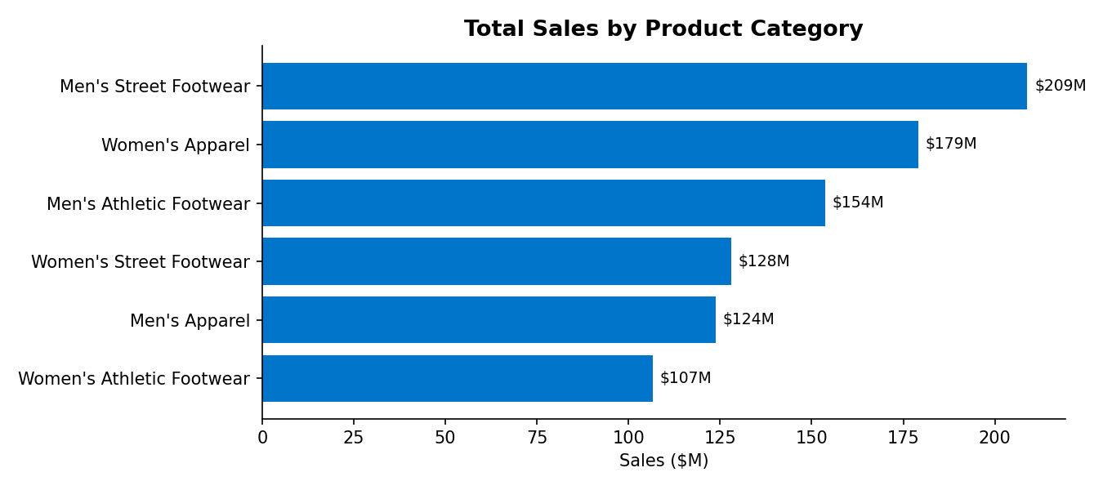
Category | Sales ($M) | Profit ($M) | % of Sales | Avg Margin
Men's Street Footwear | 208.8 | 82.8 | 23.2% | 44.6%
Women's Apparel | 179.0 | 68.7 | 19.9% | 44.1%
Men's Athletic Footwear | 153.7 | 51.8 | 17.1% | 40.3%
Women's Street Footwear | 128.0 | 45.1 | 14.2% | 41.0%
Men's Apparel | 123.7 | 44.8 | 13.7% | 41.3%
Women's Athletic Footwear | 106.6 | 39.0 | 11.8% | 42.4%

Footwear (street + athletic, men's + women's combined) accounts for roughly 66% of total sales, confirming footwear as Adidas's core revenue engine at retail, with apparel as a meaningful but secondary contributor (~34%).
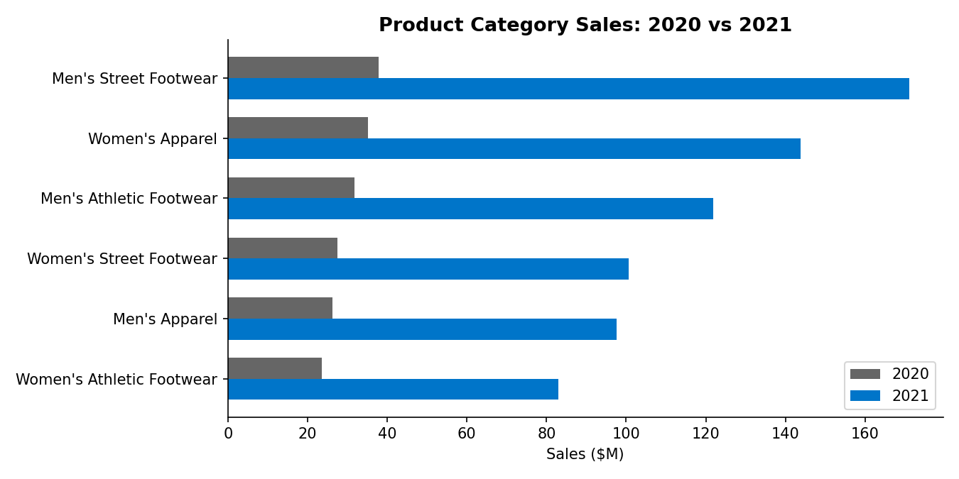
Every category grew substantially in 2021, but growth rates diverged: Men's Street Footwear grew fastest (+352%), while Women's Athletic Footwear grew slowest (+251%), though still strong. This suggests street/lifestyle footwear is outpacing performance/athletic lines in the current market — an important signal for product mix planning.

3. Retail Partner Performance
Retailer performance is highly uneven. West Gear and Foot Locker are the anchor partners; Walmart and Amazon are comparatively underdeveloped.
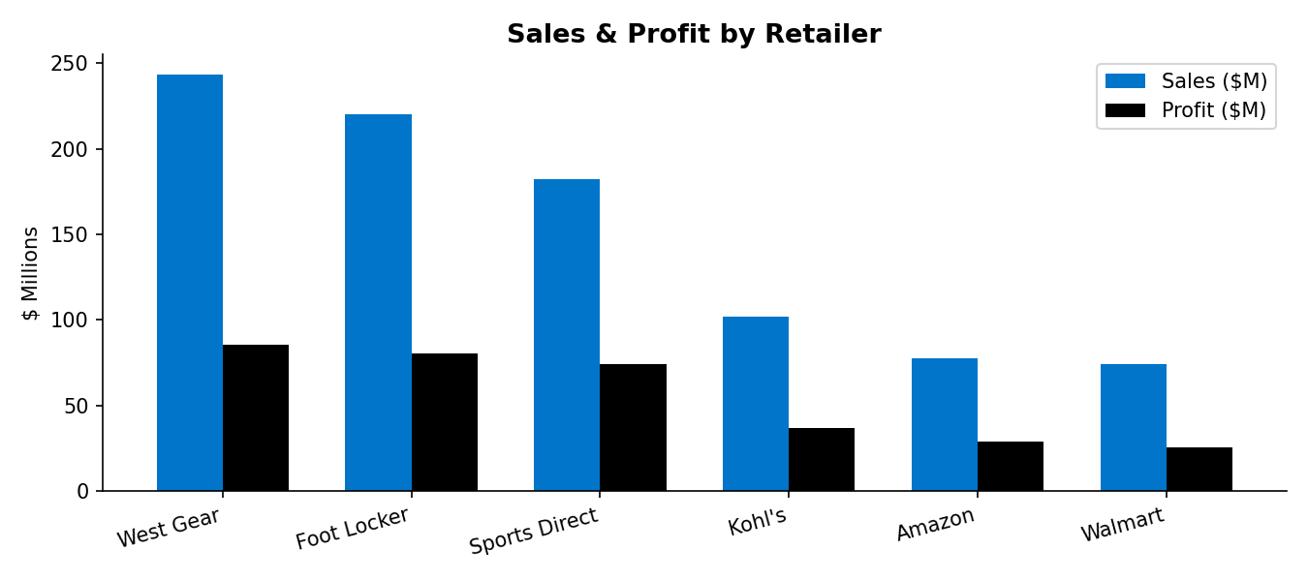
Retailer | Sales ($M) | Profit ($M) | % of Sales | Avg Margin
West Gear | 243.0 | 85.7 | 27.0% | 37.5%
Foot Locker | 220.1 | 80.7 | 24.5% | 40.0%
Sports Direct | 182.5 | 74.3 | 20.3% | 45.6%
Kohl's | 102.1 | 36.8 | 11.3% | 40.9%
Amazon | 77.7 | 28.8 | 8.6% | 41.9%
Walmart | 74.6 | 25.8 | 8.3% | 38.1%

Notably, Sports Direct posts the strongest average margin (45.6%) despite ranking third in volume — indicating disciplined pricing or a favorable product mix that other partners could learn from. West Gear leans heavily on in-store sales (64% of its volume), while Walmart and Amazon are comparatively balanced across channels but simply generate low absolute volume, suggesting under-investment or weak shelf/placement presence rather than a structural problem.

4. Regional & Geographic Performance
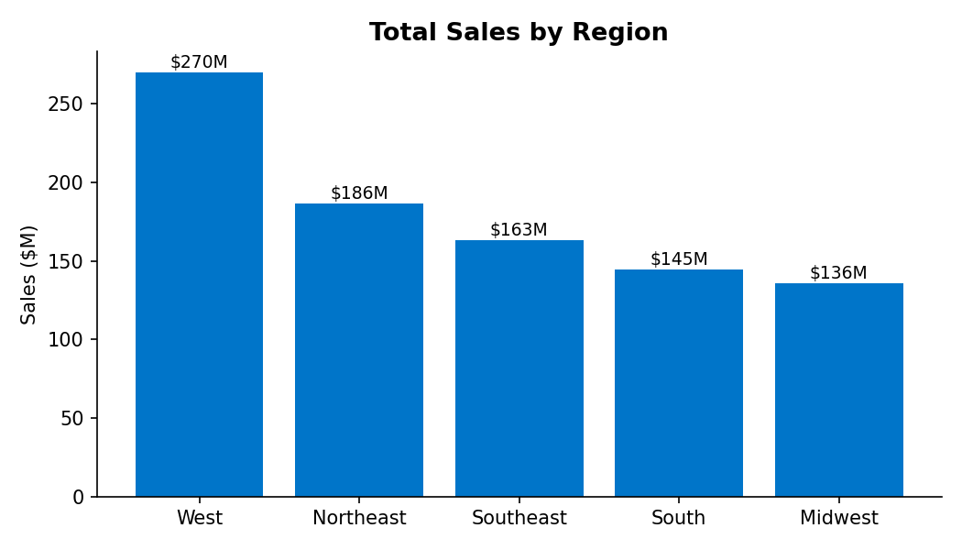
Region | Sales ($M) | Profit ($M) | % of Sales | Avg Margin
West | 269.9 | 89.6 | 30.0% | 40.0%
Northeast | 186.3 | 68.0 | 20.7% | 41.0%
Southeast | 163.2 | 60.6 | 18.1% | 42.0%
South | 144.7 | 61.1 | 16.1% | 47.0%
Midwest | 135.8 | 52.8 | 15.1% | 44.0%

At the state level, New York ($64.2M), California ($60.2M), Florida ($59.3M), and Texas ($46.4M) are the four strongest markets — together representing roughly 25% of total sales. At the other end, Nebraska, Minnesota, Iowa, Wisconsin, and North Dakota each contribute under 1% of sales apiece, pointing to significant white space in the Midwest and parts of the Northern Plains.
Interestingly, the South region posts the highest average margin (47%) despite mid-tier volume, suggesting pricing power or lower discounting pressure there relative to the higher-volume West.

5. Sales Channel Effectiveness (In-Store vs. Outlet vs. Online)
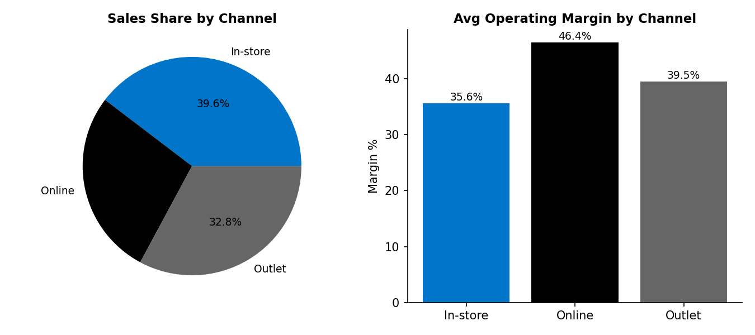
Sales Method | Sales ($M) | Profit ($M) | % of Sales | Units Sold | Avg Margin
In-store | 356.6 | 127.6 | 39.6% | 689,990 | 36%
Outlet | 295.6 | 108.0 | 32.8% | 849,778 | 39%
Online | 247.7 | 96.6 | 27.5% | 939,093 | 46%

This is one of the most strategically important findings in the dataset: Online generates the fewest sales dollars but the most units sold and by far the best margin (46% vs. 36% for in-store). This typically reflects lower fulfillment/overhead cost structure and less markdown pressure online. In-store still leads on revenue today, largely on the back of West Gear's heavy in-store footprint, but channel economics clearly favor continued investment in e-commerce and digital partnerships.

6. Time-Based Trends (Monthly, Quarterly, Seasonal)
Quarter | Sales ($M) | Profit ($M)
2020 Q1 | 48.9 | 16.9
2020 Q2 | 50.4 | 17.5
2020 Q3 | 55.3 | 19.4
2020 Q4 | 27.5 | 9.6
2021 Q1 | 140.5 | 50.1
2021 Q2 | 177.2 | 66.8
2021 Q3 | 210.0 | 80.1
2021 Q4 | 190.1 | 71.8

Every 2021 quarter outperformed its 2020 counterpart by wide margins, with growth accelerating through the year before a slight Q4 dip (-9.5% vs Q3) — plausibly a seasonal pattern worth validating against holiday promotional calendars and inventory timing in future years. Q3 (summer/back-to-school) is the strongest seasonal window, suggesting inventory and marketing spend should be pre-positioned by Q2.

Strategic Recommendations
Based on the findings above, the following actions are recommended across five strategic areas.

1. Product Strategy
- Double down on footwear leadership: Men's Street Footwear is the highest-revenue, highest-margin category. Prioritize new releases, colorways, and marketing spend here, and apply learnings from its pricing/margin discipline to other lines.
- Elevate Women's Apparel: Already the #2 category by revenue with strong margin (44.1%); increase assortment depth and cross-merchandising with Women's Footwear to lift basket size.
- Investigate Athletic Footwear's margin gap: Both men's and women's Athletic Footwear post the lowest margins in their gender group. Review input costs, discounting frequency, and competitive pricing pressure in the performance category.
- Lean into the street/lifestyle trend: Faster growth in street footwear versus athletic footwear (352% vs 283% for men's) suggests a broader consumer shift toward lifestyle product — a signal for future product development roadmaps.

2. Channel Optimization
- Accelerate investment in Online: Highest margin (46%) and highest unit volume of any channel, despite lowest total revenue. Fund digital marketing, D2C site experience, and expand online-exclusive drops to capture disproportionate profit growth.
- Protect Outlet as a margin-healthy volume driver: Outlet already delivers strong unit velocity (849,778 units) at a solid 39% margin — a good channel for inventory clearance without materially eroding profitability.
- Right-size in-store dependency: In-store leads on revenue but trails on margin. Work with West Gear specifically (64% in-store mix) on a phased omnichannel strategy — e.g., ship-from-store, in-store digital kiosks — to blend the reach of physical retail with online-level margins.

3. Regional Focus
- Defend and grow the West: Already the top region (30% of sales); ensure inventory allocation and marketing spend keep pace with demand to avoid stockouts in peak quarters.
- Close the Midwest gap: Lowest-performing region (15.1% of sales) with several bottom-10 states (Nebraska, Minnesota, Iowa, Wisconsin, North Dakota). Pilot targeted regional marketing, retailer floor-space negotiations, or localized promotions before assuming the region has structurally lower demand.
- Replicate South's margin discipline: The South posts the highest regional margin (47%) at moderate volume — study its pricing/promotion mix and test applying it in the West and Northeast, where volume is high but margin is average.
- Prioritize the top-4 states for flagship activations: New York, California, Florida, and Texas drive ~25% of total sales; these are natural markets for flagship stores, influencer campaigns, and premium product launches.

4. Demand Forecasting
- Build seasonality into inventory planning: Q3 is consistently the strongest quarter (summer/back-to-school); ensure production and inventory are pre-positioned by Q2 to avoid stockouts, and plan markdown/outlet allocation ahead of the Q4 slowdown.
- Establish category-level growth targets: With 250–350% category growth in 2021, historical run-rate models likely understate demand; forecasting should incorporate the accelerating trend rather than flat year-over-year assumptions, while stress-testing for the risk that 2021's growth rate normalizes.
- Monitor the Online unit-volume signal: Online already leads all channels in units sold; forecasting models should weight online demand growth heavily when planning fulfillment and logistics capacity.

5. Retailer & Partner Management
- Strengthen the West Gear and Foot Locker partnerships: These two retailers drive 51.5% of total sales — treat them as strategic accounts with joint business planning, co-op marketing funds, and priority allocation of new releases.
- Investigate the Walmart underperformance: Lowest sales (8.3%) and one of the lowest margins (38.1%). Assess whether this reflects limited SKU assortment, weak shelf placement, insufficient marketing support, or a genuine mismatch between the Walmart shopper and the Adidas brand — then decide whether to invest further or reallocate resources.
- Scale the Sports Direct margin model: Sports Direct achieves the best margin of any retailer (45.6%). Share pricing/promotional practices across the partner network where contractually possible.
- Grow Amazon deliberately: As the pure e-commerce marketplace in the mix, Amazon should be a natural beneficiary of the broader shift toward online — but currently underperforms other retailers on volume. A dedicated Amazon growth plan (advertising, Prime-exclusive bundles, fulfillment) could capture channel-level online momentum.

Appendix: Data & Methodology
This analysis is based on 9,648 transaction-level records covering January 1, 2020 through December 31, 2021, sourced from the Adidas U.S. sales dataset. Fields analyzed: Retailer, Retailer ID, Invoice Date, Region, State, City, Product category, Price per Unit, Units Sold, Total Sales, Operating Profit, Operating Margin, and Sales Method (In-store, Outlet, Online). No records contained missing values. All dollar figures are as reported in the source data; 2020 and 2021 may reflect differing coverage periods or retail footprints and should be validated against internal records before use in financial planning.

